**DAILY ONLINE ACTIVITIES SUMMARY**

|  |  |  |  |  |  |  |  |
| --- | --- | --- | --- | --- | --- | --- | --- |
| **Date:** | **02-07-2020** | | | | **Name:** | **B.A.SOHANKUMAR** | |
| **Sem & Sec** | **4TH SEM A** | | | | **USN:** | **4AL18CS013** | |
| **Online Test Summary** | | | | | | | |
| **Subject** | | **----** | | | | | |
| **Max. Marks** | | **----** | | **Score** | | **----** | |
| **Certification Course Summary** | | | | | | | |
| **Course** | **STATISTICS FOR DATA SCIENCE** | | | | | | |
| **Certificate Provider** | | | **GLA** | **Duration** | | | **7.2 HOURS** |
| **Coding Challenges** | | | | | | | |
| **Problem Statement:1:** Write a Java Program minimize the maximum difference between adjacent elements in an array. | | | | | | | |
| **Status: EXECUTED** | | | | | | | |
| **Uploaded the report in Github** | | | | **YES** | | | |
| **If yes Repository name** | | | | **LOCKDOWN CODING** | | | |
| **Uploaded the report in slack** | | | | **YES** | | | |

**ONLINE CERTIFICATION COURSE:**

Course: Statistics for data science

Today I have opted this new course and this course has a video content of 7.2 hours.And completed topics today on this topic are Introduction to the Course,Basics of Statistics,Descriptive Statistics,Cardio Good Fitness Case Study for Descriptive Statistics,Measures of Central Tendency,Measures of Dispersion,Understanding Distributions & Histograms,Box Plots,Summarising Data,Pair Plots,Types of Data,Univariate statistical plots and usage.

 

**CODING CHALLENGES DETAILS**:

1.Write a Java Program minimize the maximum difference between adjacent elements in an array.

Given a non-decreasing array arr[] and an integer K, the task is to remove K elements from the array such that maximum difference between adjacent element is minimum.

Note: K < N – 2

Examples:Input: arr[] = {3, 7, 8, 10, 14}, K = 2

Output: 2

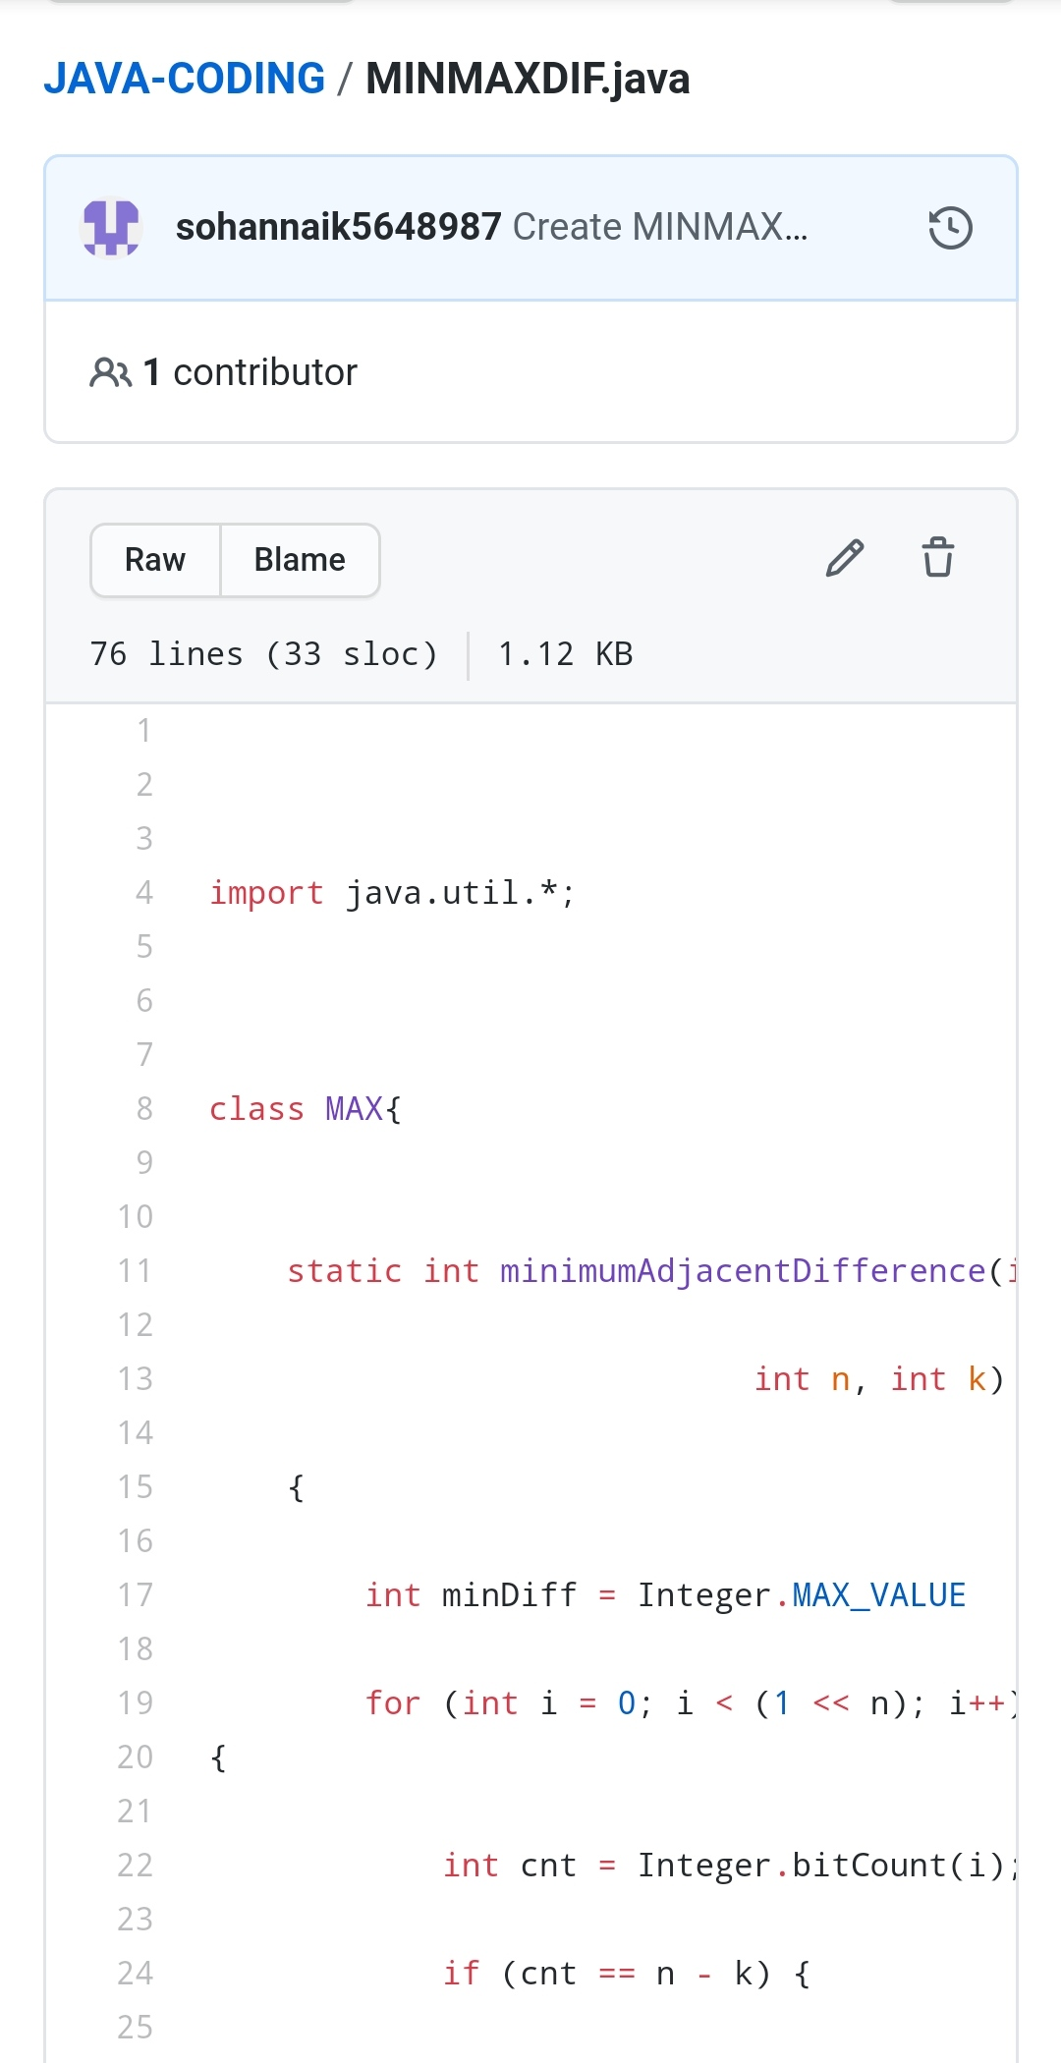

REPOSITORY LINK:https://github.com/sohannaik5648987/JAVA-CODING